SOP for adding a New Person in PACE:
Before adding a new person make sure you followed the SOP for searching if a patient is already in PACE. We want to avoid duplicates if possible and less data entry if already in PACE.
Under Person Click on Add New:
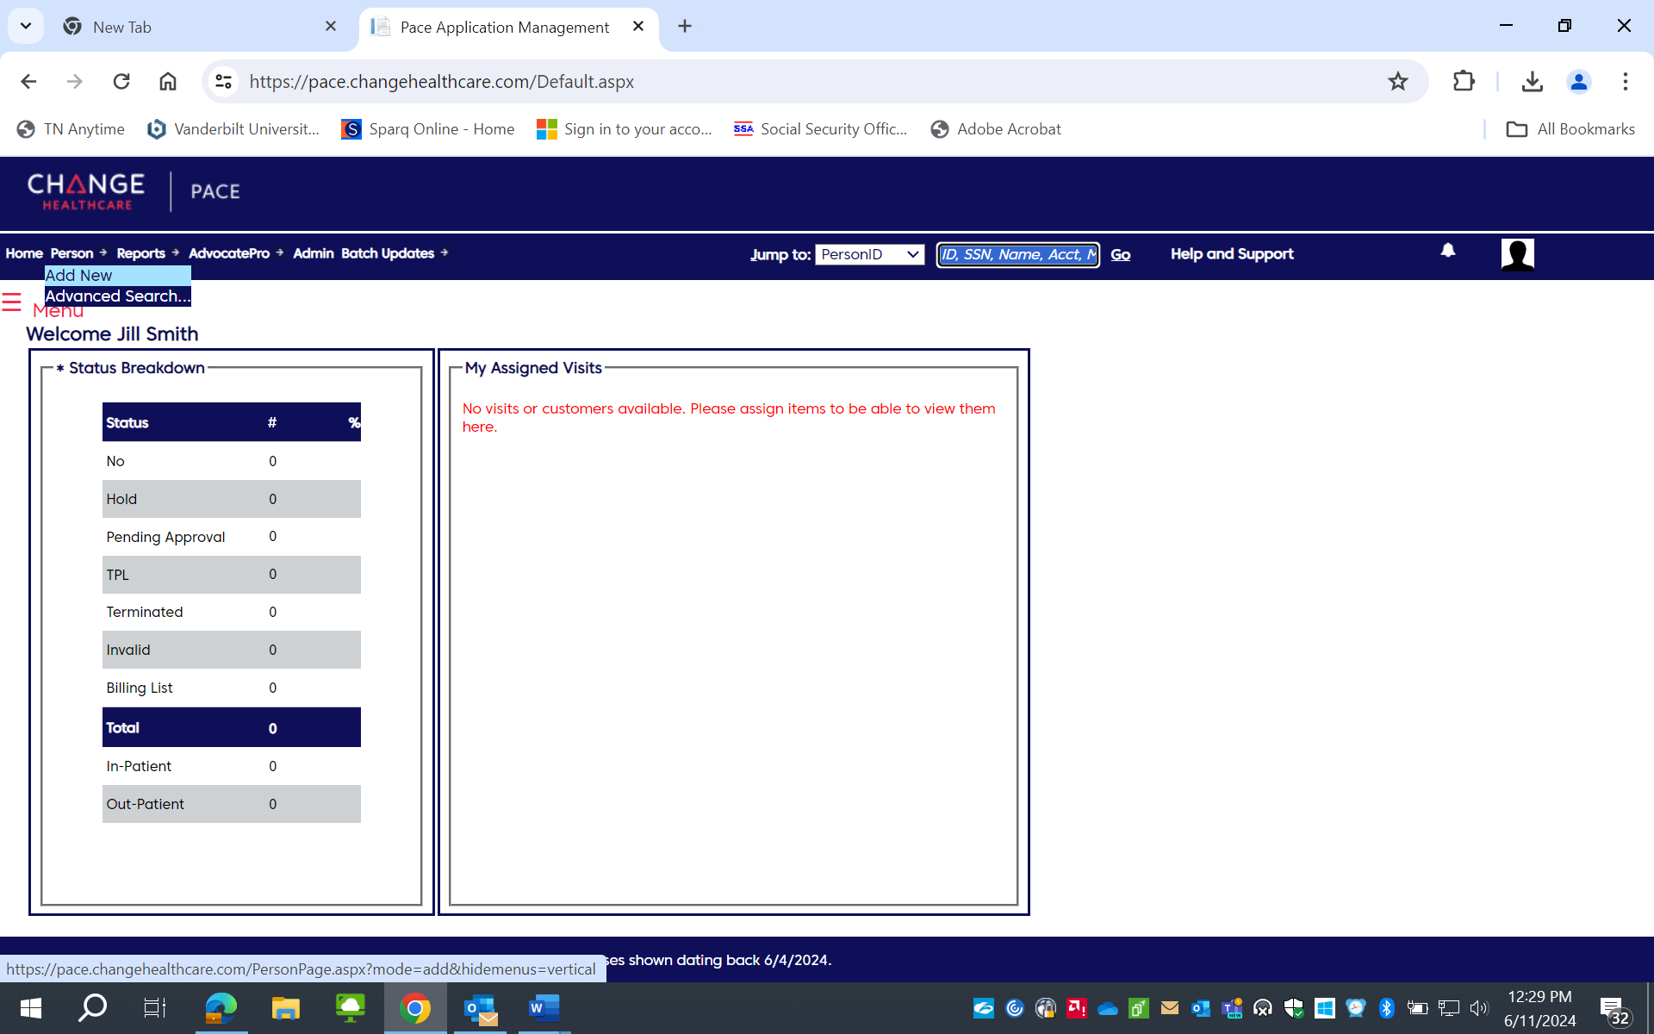
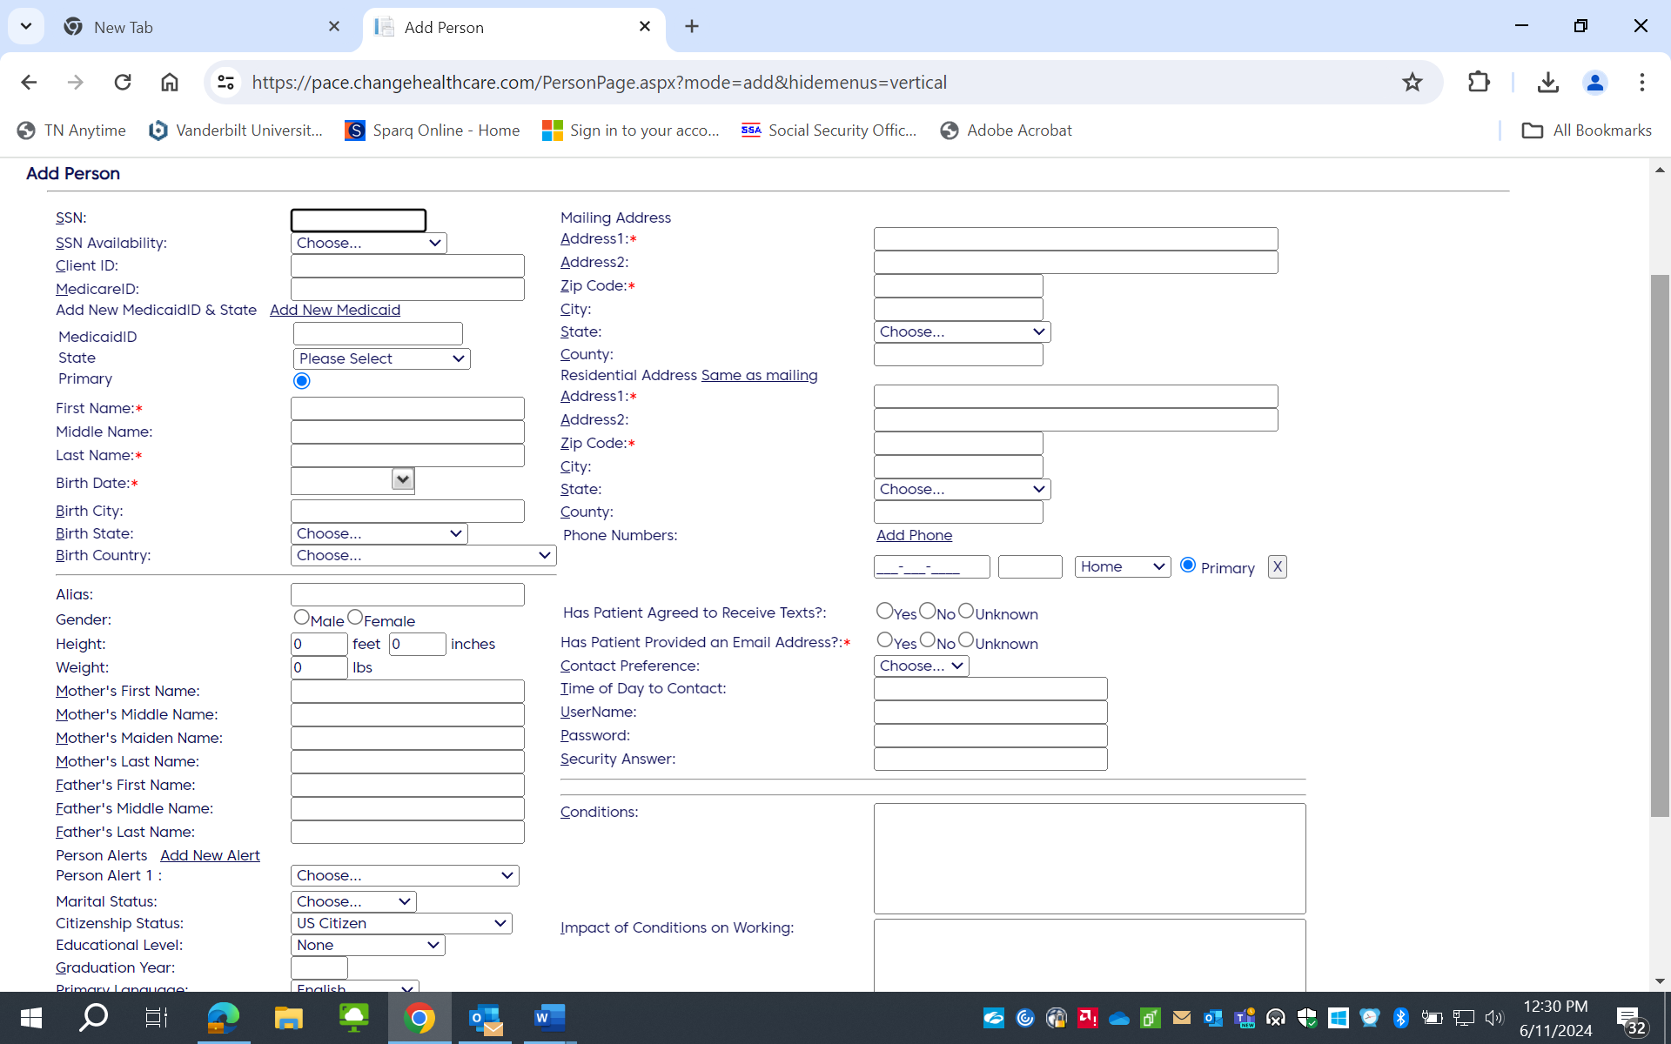

You should see this screen below and need to fill out as much information that you have:
Shortcut: type in address and tab down to zip code and type in zip code hit enter the city and state will auto populate for you
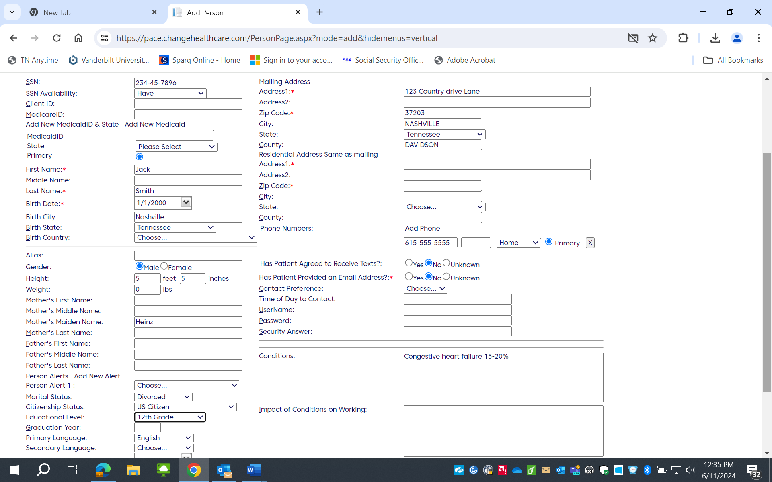
Select continue to visit page:
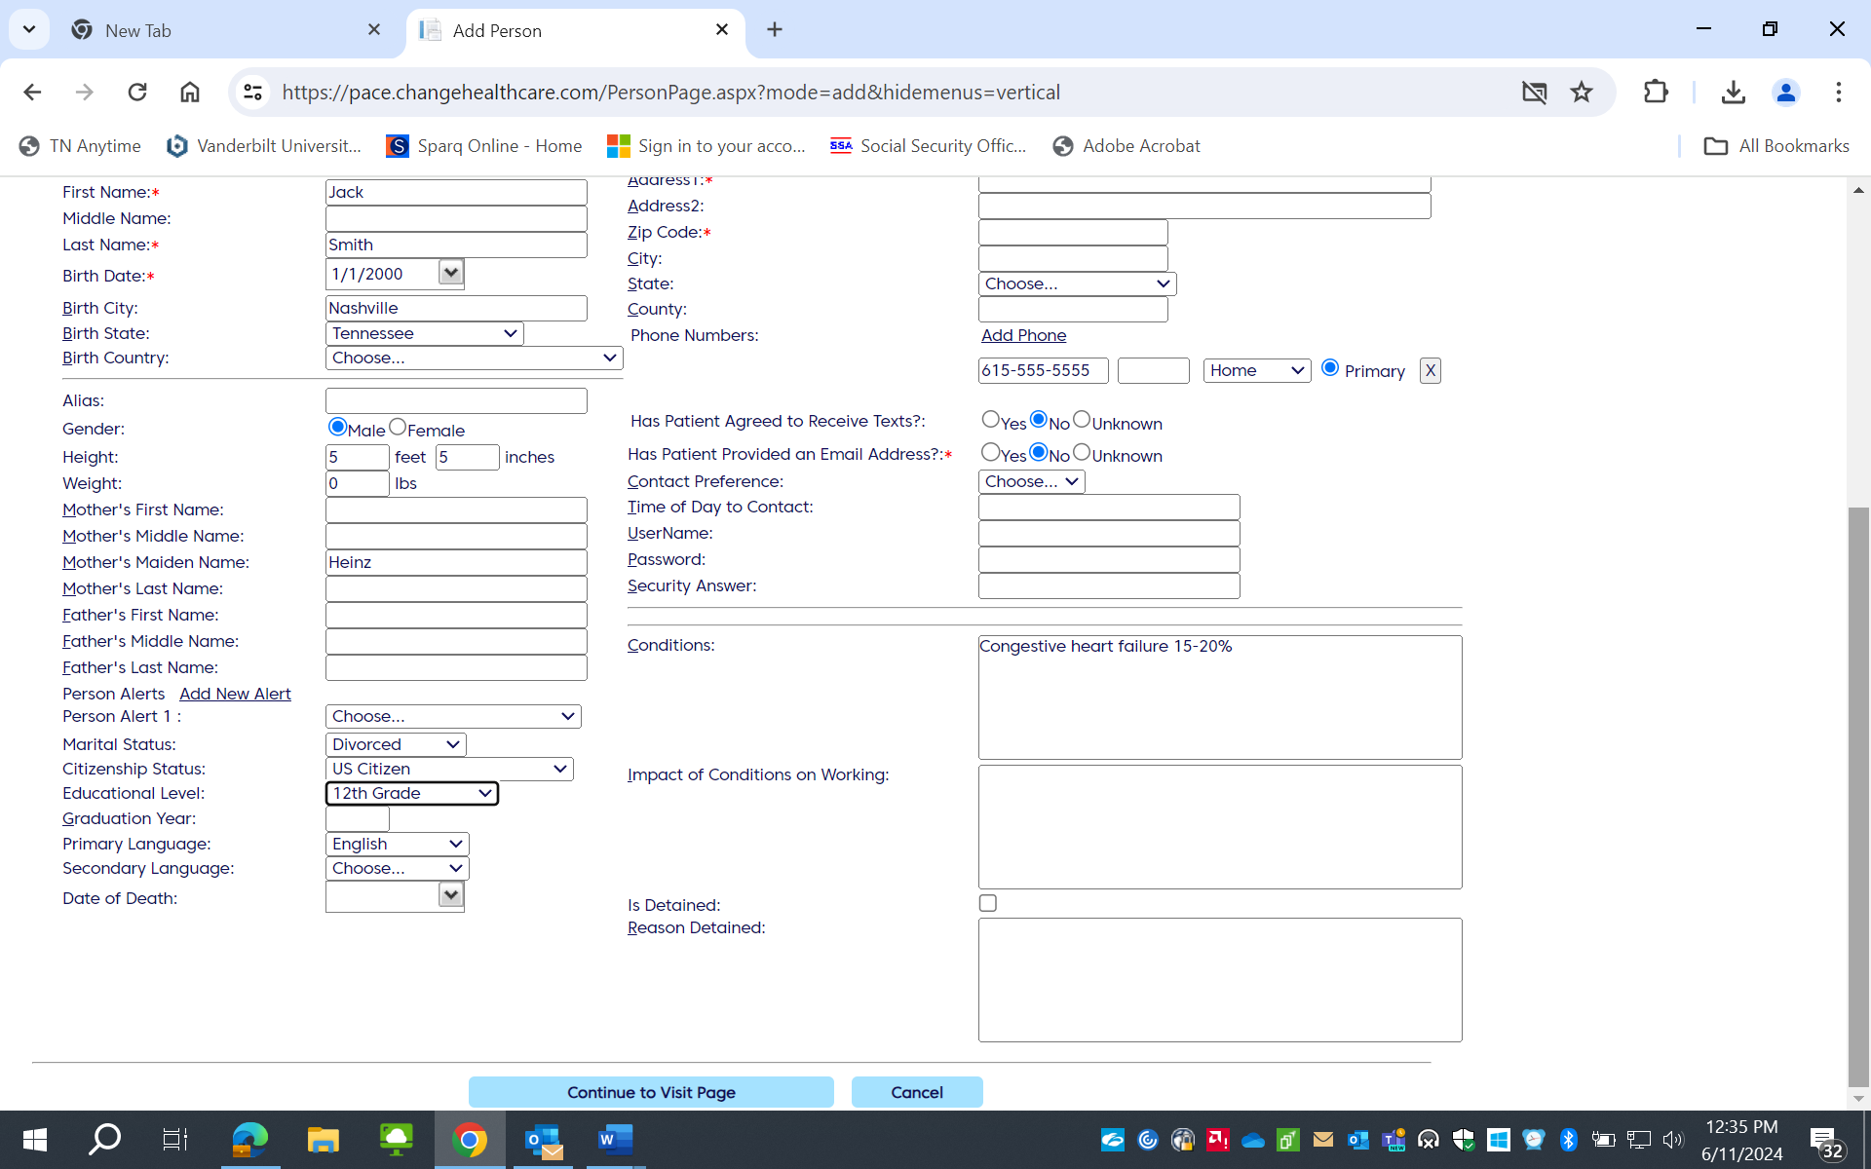

Need to fill out everything with Red Asterix: If there are screening notes then pt was screened so you can fill in the date as referral date if not sure, then click save when you scroll down to bottom of page.
